**Aim:**

**LAB # 8 (Dictionary\Set\Tuple)**

**EXERCISE - 1**

Each new term in the Fibonacci sequence is generated by adding the previous two terms. By

Starting with 1 and 2, the first 10 terms will be: 1, 2, 3, 5, 8, 13, 21, 34, 55, 89... By considering the terms in the Fibonacci sequence whose values do not exceed four million, find the sum of the even valued terms.

## Description:

The Fibonacci sequence is a series of numbers where a number is found by adding up the two numbers before it. Starting with 0 and 1, the series will be 0, 1, 1,2,3,5,8,13 and so forth.

EXAMAPLE:

0+1=1

1+1=2

1+2=3

2+3=5 SO ON

In mathematical terms, the sequence Fn of Fibonacci numbers is defined by the Recurrence relation:

Fn = Fn-1 + Fn-2

With initial values F0 = 0 and F1 = 1

## Algorithm:

**Output**: Sum of even Fibonacci numbers below 4 million Step1: Start

Step2: Initialize fib1 to 1, fib2 to 2 ,SUM

Step3: Add fib1 and fib2 and store the result in fib3 Step4: Repeat Steps 5 to 9 until fib3 < 4000000

Step5: Check whether fib3 is divisible by 2 or not. If yes, goto Step6. Otherwise, goto step7 Step6: Add fib3 to sum and store the result in sum

Step7: Set fib1 to fib2 Step8: Set fib2 to fib3

Step9: Add fib1 and fib2 and store the result in fib3 Step10: Display sum

Step11: Stop

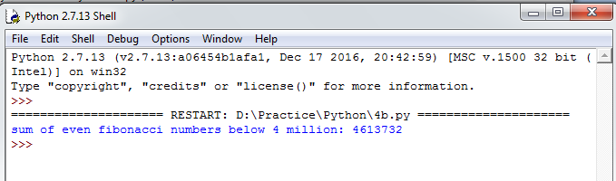

## Questions:

1. What is the return type of range() function?
2. What is the output of range(20) ?
3. What is the output of range(1,8,2)?
4. What is the output of range(100,30,-20)?
5. What is the purpose of break statement in python?
6. What is the purpose of continue statement in python?
7. What is the purpose of pass statement in python?
8. Explain the execution process of for...in ?
9. Does continue statement works without loops?
10. Which statement is used for writing empty loops? Explain with an example.

## Aim:

**EXERCISE - 2**

Write a program to count the numbers of characters in the string and store them in a

Dictionary data structure.

## Description:

Traverse each character in the string and its occurrence is stored in the dictionary. Here, we are using a String and a Dictionary.

## String:

A String is a sequence of characters. Strings can be created by enclosing characters inside a single quote or double quotes. Even triple quotes can be used in Python but generally used to represent multiline strings and docstrings.

For reading strings in Python2.7, we are using raw_input(). This function reads a line from input(i.e., the user) and returns a string by stripping a trailing new line.

## Dictionary:

The dictionary is Pythons built-in mapping type. Dictionaries map keys to values and these

<key,value> pairs provides a useful way to store data in python. The only way to access the value part of the dictionary is by using the key.

We can specify the dictionary <key,value> pairs between „{„ and „}‟. <key,value> pairs are specified as a list(separated by commas).

## Algorithm:

**Input:** A String

**Output**: A Dictionary with keys (characters in the string) and values (frequency of corresponding characters)

Step1: Start

Step2: Read the string input_str

Step2: Create an empty dictionary dict_str

Step3: Repeat Steps 4 to 6 until the end of input_str is reached

Step4: Check whether the ith character is present in the dictionary dict_str as a key element or not. If yes, goto Step5. Otherwise, goto Step6

Step5: Increment the value of ith key element by 1 and continue with the next iteration



Step6: Assign the value of ith key element to 1 Step7: Display the dictionary dict_str

Step8: Stop

**OUTPUT SUCH AS**

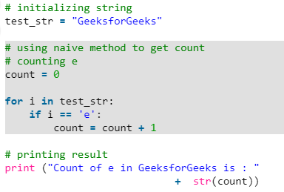

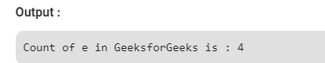

**Aim:**

**EXERCISE - 3**

Write a program to use split and join methods in the string and trace a birthday with a

dictionary data structure.

## Description:

Compare the entered birthdate with each and every person‟s date of birth in the dictionary and check whether the entered birthdate is present in the dictionary or not. Here, We are using two built-in methods of the string: split() and join().

## split():

This method breaks up a string using the specified separator and returns a list of strings. The general form of split() is as follows:

str.split(separator)

## join():

This method provides a flexible way to concatenate a string. This method returns a string in

which the string elements of a sequence have been joined by „sep‟ separator. The general form of join() is as follows:

sep.join(sequence)

Here, sequence is the sequence of elements to be joined.

## Algorithm:

**Input:** A Dictionary and a Date Of Birth

**Output**: A Message Step1: Start

Step2: Initialize the dictionary birthday to {"SANA":"15/07/1989", "ASAD":"09/12/1988", "RAZA":"11/02/2016"}

Step3: Read date in the format dd-mm-yyyy.

Step4: Split the date using the separator „-„ and store the resultant list in date_list

Step5: Join the date_list elements using the separator „/‟ and store the resultant string in dob Step6: Repeat Steps 7 and 8 until end of the dictionary is reached

Step7: Check whether dob and corresponding value(Date Of Birth) for the ith key(Person Name) element are equal or not. If yes, goto Step8

Step8: Display „Date Of Birth is found in the birthday dictionary‟ and goto Step10 Step9: Display „Date Of Birth is not found‟

Step10: Stop

## Output:

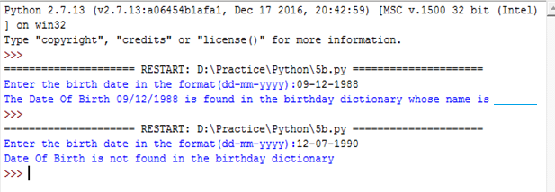

## Questions:

1. What is indexing?
2. What is the purpose of split and join method in python?
3. In Python, What is slicing?
4. What do you mean string immutable?
5. What is the use of id() function?
6. What is negative index in Python?
7. How to convert a string to all lowercase?
8. How to replaces all occurrences of old substring in string with new string?
9. How will you change case for all letters in string?
10. How to check whether the string consisting of alphanumeric characters?



## Aim:

**EXERCISE - 5**

Write a program combine_lists that combines these lists into a dictionary.

## Description:

Python offers a range of compound data types often referred to as Sequences. **List** is one of the most frequently used and very versatile data type used in Python.

In Python Programming, a List is created by placing all the elements inside a square bracket [ ], separated by commas. It can have any number of items and they may be of different types.

## Examples:

list1 = [10,20,30,40] list2 = [“SANA”,19,87.81]

Similar to string indices, list indices starts at 0 and lists can be sliced, concatenated and so

on..

Here, The task is to combine 2 lists into a dictionary. That means, One list elements will

become the keys and another list elements will become the values in the resultant dictionary.

## Algorithm:

**Input:** Two Lists **Output**: A Dictionary Step1: Start

Step2: Create two empty lists names and salaries, an empty dictionary person_dict and Initialize j=0 Step3: Read n value

Step4: Read n names into the list names Step5: Read n Salaries into the list salaries Step6: Display the lists names and salaries

Step7: Repeat Steps 8 and 9 until end of the list names is reached

Step8: Store the jth item in salaries list as value in the person_dict with key ith item in names list Step9: Increment j by 1

Step10: Display the dictionary person_dict Step11: Stop



